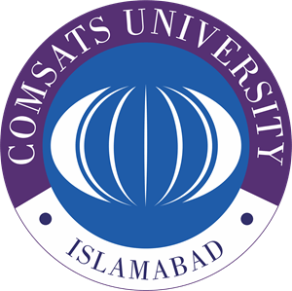

**COMSATS UNIVERSITY ISLAMABAD SAHIWAL CAMPUS**

**Presentation Fall 2023**

|  |  |  |  |
| --- | --- | --- | --- |
| Course Title: | Introduction to ICT | Course code: | CSC 101 |
| Course Instructor: | Sir Khurram Nissar | Program Name: | BSCS |
| Section: | E |

**Chosen Topic:** Cyber Crime and Security

* **Reason for choosing this Topic:** We use many devices like mobile phones, computers and laptops for storing data and we internet in our daily life but we don’t have any information about securing our data and how to become cyber safe. This presentation aims to shed light on common cyber threats, how they occur, and most importantly, how we can safeguard our digital lives. With the help this presentation, we want to give some knowledge to our classmates so that they can become cyber safe and protect their self from Cyber Attack.

**Group Members:**

1. HABIB UR REHMAN (FA23-BCS-251)
2. AREEB AHMAD (FA23-BCS-269)
3. MUZAMMAL SALEEM (FA23-BCS-247)
4. WALEED ASIF (FA23-BCS-283)